
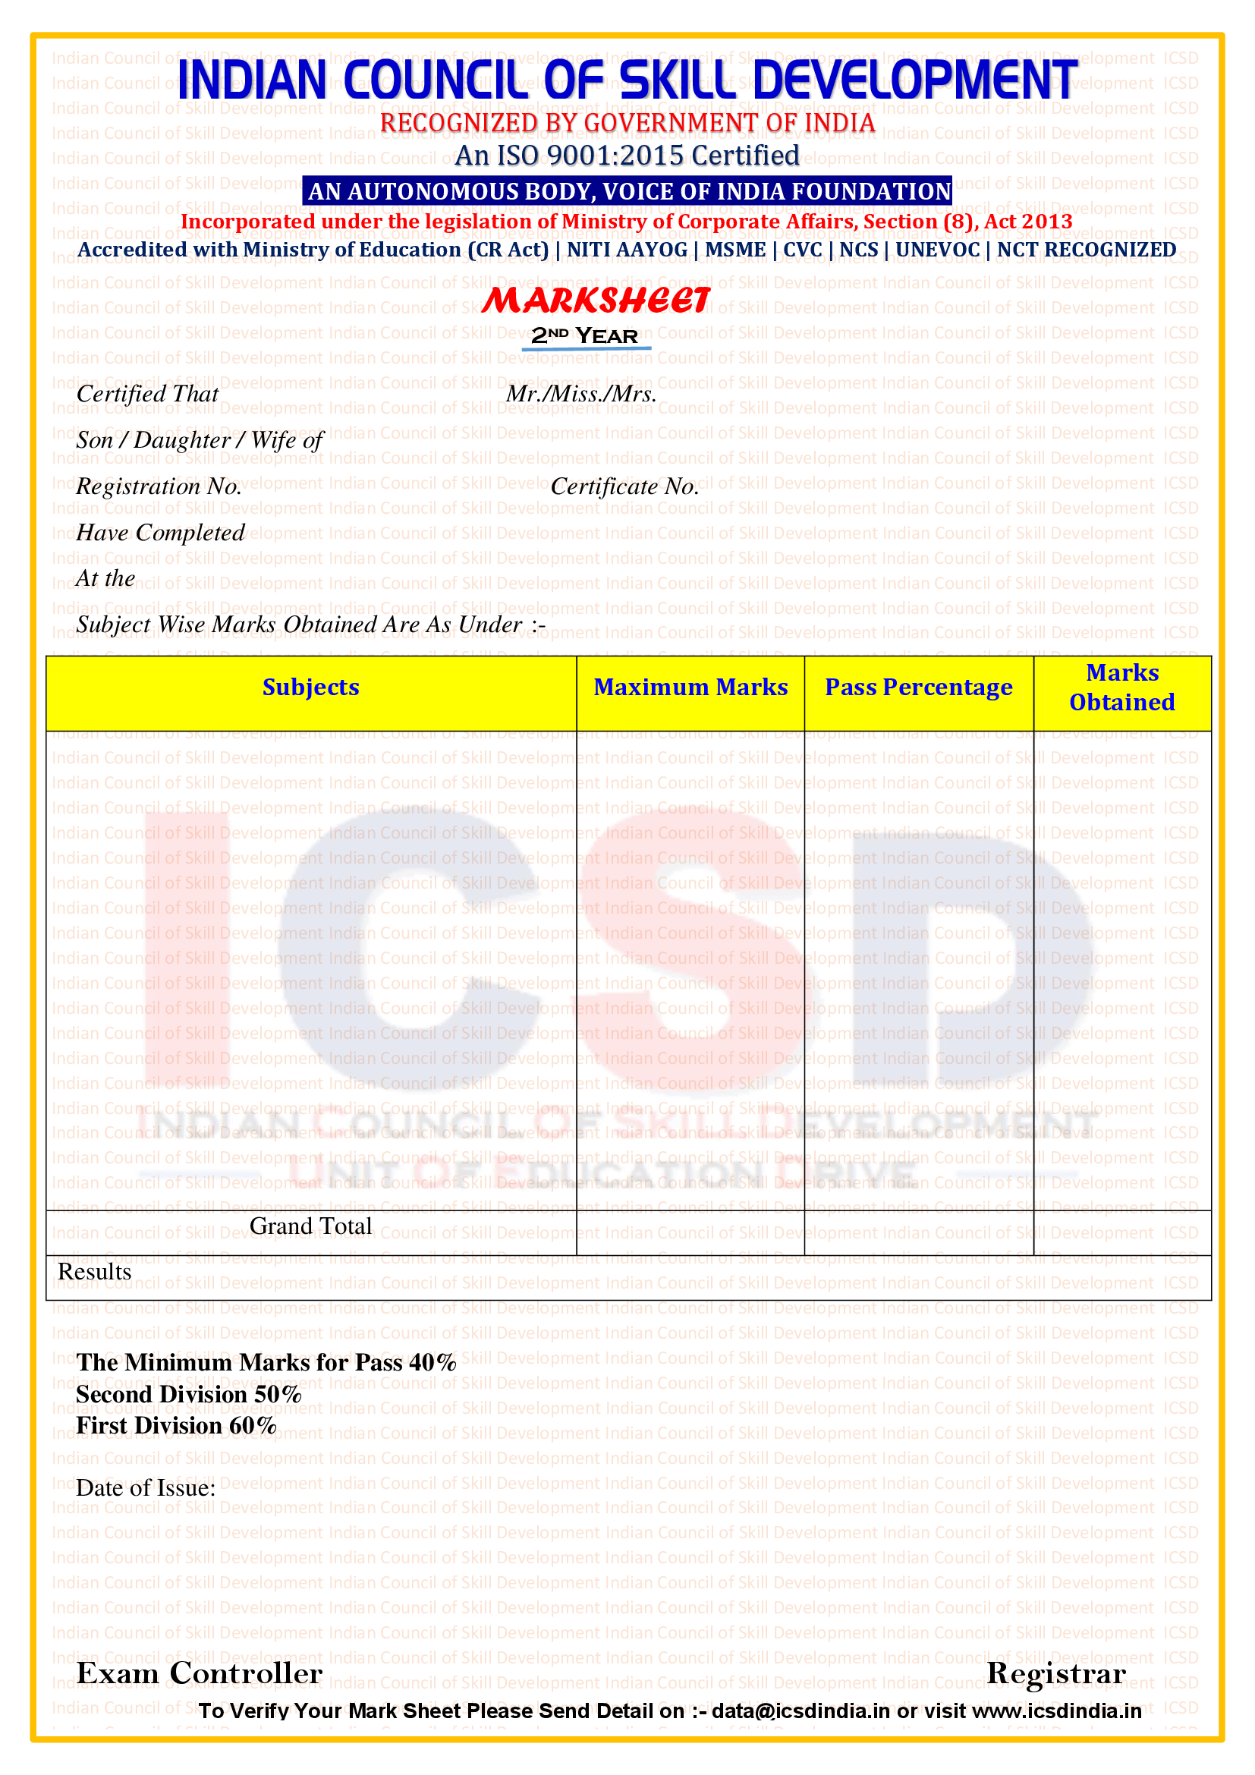


05-01-2024
36 MONTHS ADVANCED DIPLOMA IN GENERAL NURSING AND MIDWIFERY (PRIVATE)
IHCTR COMMUNITY COLLEGE(ICSD/ED/CC1101)
24-ED-20020
JYOTISHMITA DEKA


LAKHIKANTA DEKA
3RD Year
VI Semester
V Semester
ICSD20010
Passed in 1ST DIVISSION
600 40 458
HYGIENE AND SANITATION 100 40 70
COMMUNITY MEDICINE 100 40 76
PRACTICAL AND VIVA VOICE 100 40 78
CHILD HEALTH NURSING 100 40 76 MOTHER CARE 100 40 78 NUTRITION AND DIETICS 100 40 80

